Position Title | Management Accountant
Classification | SOG C
Responsible to | Chief Financial Officer
Number of direct reports | 1
Number of indirect reports | Nil

The Legal Aid Commission (ACT) (Legal Aid)
Legal Aid was established under the Legal Aid Act 1977. Its mission is to promote a just society in the Australian Capital Territory by:
→ ensuring that vulnerable and disadvantaged people receive the legal services they need to protect their rights and interests
→ developing an improved community understanding of the law, and
→ seeking reform of laws that adversely affect those we assist.

Further information about Legal Aid can be found at http://www.legalaidact.org.au
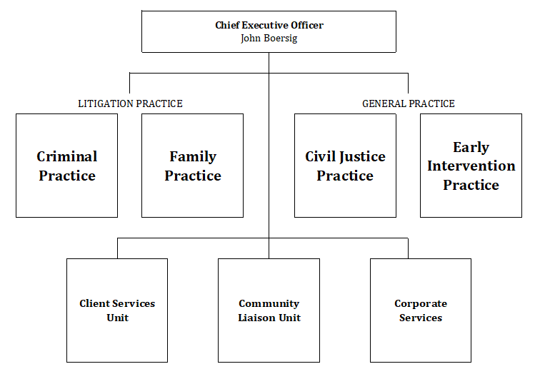

Corporate Services
Legal Aid’s Corporate Services section encompasses:
- Finance
- People & Culture
- Information & Communication Technology
- Facilities Management

Position Dimension and Relationships
The Management Accountant primarily provides oversight of Legal Aid’s management accounting, data analysis and reporting processes.

At different times, the Management Accountant will also complete project work as directed by the Chief Financial Officer or the Chief Executive Officer relating to Legal Aid’s financial and administrative processes.

Essential Duties and Responsibilities
Under general direction, the Management Accountant will:
- Represent Legal Aid in a professional manner by upholding the ACT Public Service Values
- Oversight Legal Aid’s management accounting & reporting processes, including the submission of regular and ad-hoc reporting requirements
- Prepare, maintain and report on budgets for internal work areas within Legal Aid
- Assist with the external budget preparation for Legal Aid, including preparing funding business cases
- Manage the analysis and presentation of data, including the regular financial report to the Board of Commissioners
- Oversight the numerous financial contracts associated with Legal Aid
- Contribute to the preparation of the financial statements for Legal Aid, including liaison with the Audit Office
- Contribute to specific project work from time to time including:
- forward staffing and financial planning and recommend options under different scenarios
- involvement in preparing Legal Aid’s Annual Report
- preparing submissions for new grant funding
- Build professional relationships with employees and managers across Legal Aid to deliver high-quality and seamless service delivery
- Work towards performance objectives and KPIs identified in strategic, operational and individual performance development plans
- Be responsible for applying WHS to daily tasks performed in the workplace, report all matters beyond your authority and take all practical measures to ensure that your workplace is safe and without risk to health or property
- Comply with all Legal Aid ACT policies and procedures
- Perform other duties as directed, consistent with the classification level of the position and in line with competencies

Key Capabilities
Essential:
- Ability to interpret, manipulate and understand data relevant to the management and output of Legal Aid
- Excellent attention to detail and a proven ability to prepare accurate, timely and comprehensive reports
- High level written and verbal communication skills, including the ability to clearly present data in an accurate and concise manner
- Ability to interpret and apply appropriate legislation.
- Excellent knowledge and application of relevant accounting standards and principles
- Ability to assess priorities and manage competing deadlines both independently and as a member of a team
- Initiative, sound judgment and the capacity to respond to requests for assistance in urgent matters while working in a team environment

Requirements:
- Relevant qualifications in accounting or finance (preferably with CA/CPA qualification)

